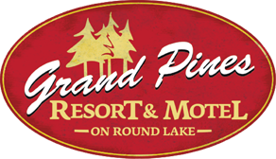

Wedding Package at Grand Pines Motel on Little Round Lake

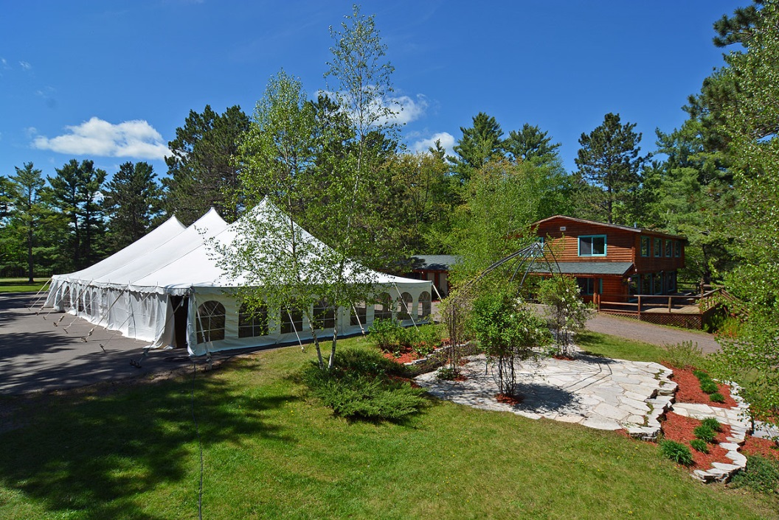

3 Day Exclusive Event Includes…
- Friday and Saturday, plus your choice of Thursday or Sunday
- Use of entire Grand Pines Motel Grounds privately
- All 10 Motel rooms for guests Friday and Saturday nights
- Executive Cabins 28 and 29 all 3 nights
- Honeymoon Cabin 30 all 3 nights
- Use of Whispering Pines space for setup, staging, catering and restrooms
- Access to Motel parking lot and grounds for tent setup, client to arrange
- Staff available to assist with onsite details
- All caterers must be licensed
- Cost starting at $5,342 before applicable taxes
    - The cost represents what the Resort expects from the entire wedding event. Motel rooms and Cabins can be paid for by the individual guests; however, any unused rooms are the responsibility of the wedding party.

Grand Pines Resort Lodging is available for groups at a discounted rate during certain times of the year. Please contact our Grand Pines Group Representative about your event today!

Looking for some additional activities for your group…we can accommodate that for you as well. We look forward to working with you and your group! Contact us at 715-462-4006 or grandpinesgroups@gmail.com.

